**package** com.client;

**import** java.io.*;

**import** java.util.*;

**import** com.servermain.operations.BusinessLevelOperations;

**public** **class** AppMain {

**private** **static** Scanner *sc*;

**public** **static** **void** main(String[] args) {

*welcomeScreen*();

**try** {

*menuDriven*();

} **catch** (FileNotFoundException e) {

// **TODO** Auto-generated catch block

e.printStackTrace();

}

}

**public** **static** **void** welcomeScreen() {

System.***out***.println("Application Name : MAIN APPLICATION \n");

System.***out***.println("Developer Details: Developed by MANISURYA UDHISI \n");

}

**public** **static** **void** menuDriven() **throws** FileNotFoundException {

*sc* = **new** Scanner(System.***in***);

BusinessLevelOperations obj = **new** BusinessLevelOperations();

**int** option;

**do** {

System.***out***.println("Enter your choice which you want to select: \n");

System.***out***.println("\t1. Retrieve current filenames in ascending order \n");

System.***out***.println("\t2. Business-level operation menu \n");

System.***out***.println("\t3. Exit from the application \n");

option=*sc*.nextInt();

**switch**(option) {

**case** 1:

obj.showAllFiles();

**break**;

**case** 2:

**int** ch;

**do** {

System.***out***.println("Enter your choice for Business level operation");

System.***out***.println("\t1. Add a file and its content to a directory");

System.***out***.println("\t2. Delete a file from a directory");

System.***out***.println("\t3. Searching a file and showing its content");

System.***out***.println("\t4. Exit from BOL menu");

ch=*sc*.nextInt();

**switch**(ch) {

**case** 1:

obj.addFile();

**break**;

**case** 2:

obj.deleteFile();

**break**;

**case** 3:

obj.searchFile();

**break**;

**case** 4:

System.***out***.println("Exited from the Business Level operation...");

System.***out***.println("---------------------------------\n");

**break**;

**default**:

System.***out***.println("Invalid Choice");

**break**;

}

}**while**(ch!=4);

**break**;

**case** 3:

System.***out***.println("Exiting from the application...");

**break**;

**default**:

System.***out***.println("Invalid choice");

}

//System.out.println("Press 0 to continue");

}**while**(option!=3);

}

}

**package** com.server2;

**public** **interface** FileInterface {

**public** **void** showAllFiles();

**public** **void** addFile();

**public** **void** deleteFile();

**abstract** **void** searchFile();

}

**package** com.servermain.operations;

**import** com.server2.*;

**import** java.awt.Desktop;

**import** java.io.File;

**import** java.io.FileNotFoundException;

**import** java.io.IOException;

**import** java.util.*;

**public** **class** BusinessLevelOperations **implements** FileInterface {

List<String> retrieve= **new** ArrayList<String>();

File[] files = **new** File("C:\\Users\\lenovo\\eclipse-workspac").listFiles();

**private** Scanner scan;

**private** Scanner scan2;

**private** Scanner scan3;

**private** Scanner sc1;

@Override

**public** **void** showAllFiles() {

// **TODO** Auto-generated method stub

**for**(File file : files) {

**if**(file.isFile()) {

retrieve.add(file.getName());

//System.out.println(file.getName());

}

}

retrieve.forEach(System.***out***::println);

}

@Override

**public** **void** addFile() {

// **TODO** Auto-generated method stub

System.***out***.println("Enter the file which you want to add:");

scan = **new** Scanner(System.***in***);

String filename=scan.nextLine();

File F= **new** File(filename);

**try** {

**if**(F.createNewFile()) {

System.***out***.println(filename+" file is added to the directory");

Desktop.*getDesktop*().edit(F);

}

**else** {

System.***out***.println("This file is already there");

}

} **catch** (IOException e) {

// **TODO** Auto-generated catch block

e.printStackTrace();

}

}

@Override

**public** **void** deleteFile() {

// **TODO** Auto-generated method stub

System.***out***.println("Enter the file which you want to delete:");

scan2 = **new** Scanner(System.***in***);

String filename=scan2.nextLine();

File F= **new** File(filename);

**if**(F.delete())

System.***out***.println(filename+" got Deleted");

**else**

System.***out***.println("File Not Found");

}

@Override

**public** **void** searchFile() {

// **TODO** Auto-generated method stub

**try** {

scan3 = **new** Scanner(System.***in***);

File directory = **new** File("C:\\Users\\DELL\\eclipse-workspace");

System.***out***.println("Enter the file name which you want to search:");

String fileName=scan3.nextLine();

File[] files=directory.listFiles();

**int** flag=0;

**for** (File file : files) {

String name = file.getName();

**if** (name.equals(fileName)) {

// System.out.println("The filename "+fileName+" is present in the directory");

File f= **new** File(fileName);

sc1 = **new** Scanner(f);

**while**(sc1.hasNextLine()) {

System.***out***.println(sc1.nextLine());

}

flag=1;

}

}

**if**(flag==0) {

System.***out***.println("File not found");

}

}**catch**(FileNotFoundException ex) {

System.***out***.println("file not found");

}

}

}

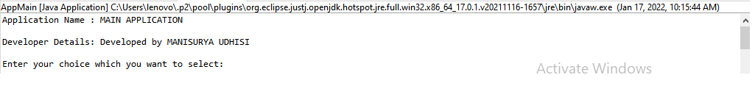

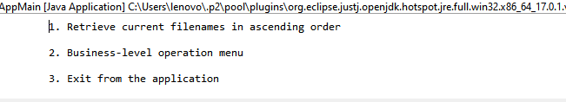

https://github.com/mansugit/mansu.git